1.Write a Java program to get a number from the user and print whether it is positive or negative.

Test Data  
Input number: 35

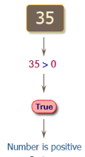

2.Write a Java program to solve quadratic equations (use if, else if and else).

Test Data  
Input a: 1  
Input b: 5  
Input c: 1

**Pictorial Presentation:**

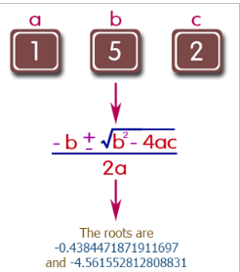

3.Take three numbers from the user and print the greatest number.

Test Data  
Input the 1st number: 25  
Input the 2nd number: 78  
Input the 3rd number: 87

**Pictorial Presentation:**

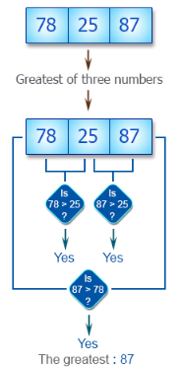

4.Write a Java program that keeps a number from the user and generates an integer between 1 and 7 and displays the name of the weekday.

Test Data  
Input number: 3

**Pictorial Presentation:**

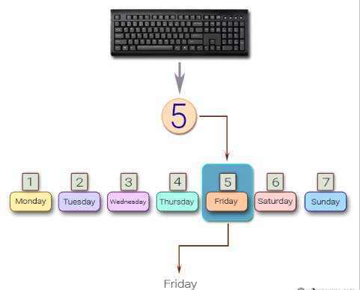

5.Write a Java program that reads in two floating-point numbers and tests whether they are the same up to three decimal places.

Test Data  
Input floating-point number: 25.586  
Input floating-point another number: 25.589

6.Write a Java program that takes the user to provide a single character from the alphabet. Print Vowel of Consonant, depending on the user input. If the user input is not a letter (between a and z or A and Z), or is a string of length > 1, print an error message.

Test Data  
Input an alphabet: p

**Pictorial Presentation:**

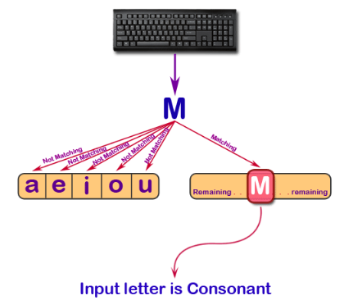

7.Write a Java program that takes a year from user and print whether that year is a leap year or not.

Test Data  
Input the year: 2016

**Pictorial Presentation:**

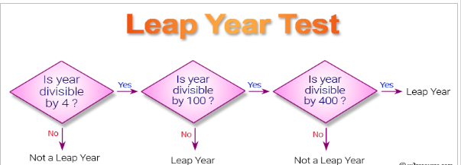

8.Write a program in Java to display the first 10 natural numbers.

**Pictorial Presentation:**

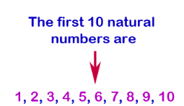

9.Write a program in Java to display n terms of natural numbers and their sum.

Test Data  
Input number: 7

**Pictorial Presentation:**

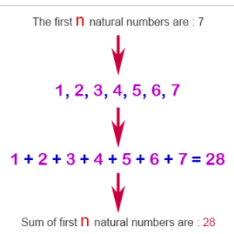

10.Write a program in Java to display the cube of the number upto given an integer.

Test Data  
Input number of terms : 4

**Pictorial Presentation:**

